Does Reminding of Behavioural Biases Increase Returns from Financial Trading? A Field Experiment

Maria De Paola∗
(Department of Economics, Statistics and Finance, University of Calabria and IZA, Bonn)

Francesca Gioia
(School of Economics, University of Edinburgh and Department of Economics, Statistics and Finance, University of Calabria)

Fabio Piluso
(Department of Business Administration, University of Calabria)

Abstract. We ran a field experiment to investigate whether nudge policies, consisting in behavioural insight messaging, help to improve performance in financial trading. Our experiment involved students enrolled in a financial trading course in an Italian University who were invited to trade on Borsa Italiana’s virtual platform. Students were randomly assigned to a control group and a treatment group. Treated students received a message reminding them of the existence of behavioural biases in financial trading. We find that treated students significantly improve the performance of their portfolio. This effect is mainly driven by students with a higher than average risk aversion. Several behaviours may explain the increase in performance. We find evidence pointing to a reduction in the home and status quo biases for risk averse nudged participants.

JEL classification: D14, E21, E22, O16
Keywords: financial trading, behavioural biases, reminders, nudges, home bias, status quo bias, risk aversion

Introduction
Behavioural economics, integrating insights from psychology, neuroscience and sociology, has been applied in many domains, such as finance, consumption and education, to better understand individual decisions. People are not fully rational and thus their decisions might be at least partially driven by behavioural biases. The relevance of these biases in financial decisions has long been recognized. While traditional theories are based on the assumption that investors act in a rational manner (see among others Muth, 1961; Samuelson, 1965; Fama, 1970; Ross, 1976; Van Neumann and Moorgester, 1994), more recent approaches (see Shleifer, 2000) consider that investors face several cognitive and psychological errors. A number of empirical papers show that investors suffer from: overreaction, reference point thinking, loss aversion, overconfidence, home bias, limited attention etc. (see among others Tversky, 1990; Odean, 1998; Shefrin, 2000; Barberis and Thaler, 2003; Thorley, 2006, Frazzini, 2006).
Even if biases and heuristics can help to make decisions in some particular circumstances, for instance when a more comprehensive and careful decision-making process is not possible, in other circumstances they can determine inefficient choices. A number of papers document that limitations in attention, memory and self-control can bring individuals to undertake choices that are against their long-run self-interest (for a review of the literature see Rabin, 1999, and DellaVigna, 2009). For instance, in the domain of financial decisions, Barber and Odean (2000) and Biais et al. (2005) show that overconfidence leads to excessive trading with negative consequences on returns (when transaction costs are considered). Similarly, home bias and status quo bias can lead investors to ignore profitable investment opportunities, that involve foreign companies or alter the current portfolio composition, and to diversify not efficiently their portfolio.
The existence of behavioural biases that lead to sub-optimal results might motivate interventions that target such biases. Among these interventions, special attention has been recently devoted to nudging, that is the implementation of policies aimed at “altering people behaviour in a predictable way without forbidding any options or significantly changing economic incentives” (Thaler and Sunstein, 2008). Nudging includes a number of different tools such as defaults, priming, framing, easy access to information, reminders. The appeal of nudges is partially due to the fact that they can be implemented at relatively low costs. There is also evidence that these policies are effective in changing decisions; for example the specification of default option, information disclosure and labelling have been proven to strongly affect individual behaviour (Johnson and Goldstein, 2003, Wisdom et al., 2010 and Abeler and Marklein, 2010).
In this paper, we focus on simple reminder messages. The use of reminders, which help people to take actions that they might otherwise not undertake due to limited attention, has been experimented in a number of fields with positive effects. For instance, in the context of educational decisions, Castleman and Page (2015) show that text message reminders sent to students to inform them about upcoming deadlines and about enrolment requirements increase enrolment to college. Positive effects have been found also for health related decisions (see Altman and Traxler, 2014; Calzolari and Nardotto, 2014), loan repayments (Cadena and Schoar, 2011; Karlan et al., 2012), fundraising and donations (Vuletic, 2015; Damgaard et. al., 2016). As far as financial decisions are concerned, the effects of reminders have been mainly considered in relation to saving behaviour. Among the others, a recent paper by Karlan et al (2014), show that reminders increase saving and are particularly effective when they draw attention to a particular future goal. However, errors and biases affect not only saving but many other spheres of financial decisions. They can affect the choice of the portfolio composition or investors trading behaviour over time. The aim of this paper is to investigate whether providing warnings about the possibility of biases improves decision-making. More precisely, we analyse whether reminders of the existence of behavioural biases in financial trading can produce a positive effect on individuals’ investment decisions and portfolio performance.
The effect of nudge policies may differ across people as not all individuals pay the same attention or are similarly sensitive to gentle reminders. In particular, we suggest that participants’ reaction to behavioural insight messaging differs depending on individual risk attitudes, with risk averse participants being more influenced as they may perceive the message as a hint to attenuate the risk while trading.
The contribution of our paper is threefold. First, we investigate the effects of reminders in a special domain, that is individuals’ financial trading decisions. Second, while the existing literature has investigated the effect of interventions aimed at reminding specific information, such as deadlines or goals, our study focusses on the effects of reminders with a broader content that call individuals’ attention to a more general issue (i.e. cognitive biases that might affect their choices) and give them the opportunity to think about several aspects of their decisions. Reminders may help them to act in a less impulsive way and try to consider factors that otherwise they would disregard. To the best of our knowledge this is the first paper studying the impact of behavioural insights reminders on investment and trading decisions. Last but not least, we hypothesise and test an heterogeneous impact of reminders depending on individual risk attitudes.
We answer our research question by running a field experiment with 193 undergraduate students attending a Financial Trading course at the University of Calabria. This course covers a number of topics (e.g. financial market structure, stock-exchange listing or financial engineering operations) including a short introduction to behavioural biases in financial decisions. More precisely, a two-hour lesson was devoted at discussing excessive optimism, overconfidence, home bias, excessive trading, framing effects, status quo bias, confirmation bias and loss aversion bias. Students enrolled in the course by filling in a questionnaire containing, among the others, a question on their risk aversion.
Students attending the course were invited to undertake an optional activity consisting in trading on a virtual platform available at the Borsa Italiana’s website, called Borsa Virtuale. This activity allowed them to get a bonus to add to the exam grade. Students joining the optional activity were then randomized into a treatment and a control group according to a stratified randomization procedure. After half of the time available to trade on this virtual platform, students in the treatment group received a message reminding them of both the rules that they had to respect in order to gain the bonus and the existence of behavioural biases in financial trading. Instead, students in the control group received a message reminding only of the requirements for gaining the bonus. We decided to send a message also to control students in order to avoid Hawthorne effects and externalities: if all students receive a message, students are less likely to interact in order to exchange information about it so the difference in the content is less likely to emerge. Moreover, we circumvent potential externalities between treated and control students by sending out these messages when the course was over and, more importantly, students were no longer at the University because of Christmas vacations.
We find a positive and statistically significant effect of our message on students’ performance at the trading game. The return they got increased by about 1.8 percentage points. As suggested, this effect is mainly driven by risk averse students who seem to particularly benefit from our “nudge”.
The increase in performance following the reminder may be driven by a change in several dimensions of trading due to participants trying to attenuate different biases. With the data at hand, we are not able to investigate the impact on all the biases. However, we offer some insights on the channels through which our “nudge” has worked by examining its effect on three behavioural biases: trading frequency, home bias (percentage of the portfolio value invested in foreign stocks) and status quo bias (ratio of new stocks on stocks already present in the initial portfolio). We do not find any statistically significant effect of our treatment on trading frequency. Instead, when we look at the other two biases, we find that students’ reaction to the nudge is related to their risk aversion. While more risk averse students react to the message by trying to attenuate such biases (by increasing their foreign investments or the number of new companies in which they invest), students with a risk aversion equal or lower than the average do not significantly change their behaviour in any of the dimensions we consider.
Our results confirm findings emerging from the existing literature (see for instance Morewedge and Kahneman, 2010) showing that even individuals with good financial education and who are aware of behavioural biases undertake financial decisions that can be hardly explained by theories based on full rationality. For instance, our sample students show a strong home bias and little portfolio diversification. More importantly, our findings document that simple reminder messages reinforcing information that individuals already have can positively affect financial choices and increase portfolio returns. This evidence supports the idea that when taking decisions individuals tend to not consider all the information they have and that calling their attention to relevant aspects can improve their decision-making.
The paper is organized as follows. Section 2 reviews the existing literature. In Section 3 we describe the experiment, present the data and conduct some balance checks. In Section 4 we carry out our main empirical analysis. Section 5 concludes.

Related Literature
Studies on behavioural finance have started since the seventies when the rational investor assumption and the consequent thesis of efficient markets have been questioned by several authors, including Herbert Simon who, instead of “utility maximization by a rational investor”, refers to the concept of “limited investor rationality”.
The economic and psychological literature has documented many patterns on how people deviate from full rationality. They arise from different types of cognitive biases: people tend to be overconfident about their ability, to rely on rules of thumb, to prefer familiar situations, to put more weight on recent experience, to pay attention on how choices are framed etc. These biases can explain some widely documented phenomena, such as investors reluctance to sell assets trading at a loss relative to the price at which they were purchased (disposition effect), limited diversification, excessive trading and investors tendency to buy stocks that in the past had particularly bad or good performances (attention-getting assets).
In our work, we mainly focus on home bias, status quo bias and trading frequency. Many empirical works show that investors diversify their portfolio much less than suggested by normative models of portfolio choice. Under-diversification is strictly related to the so-called home bias: investors in the USA, Japan and the UK allocate 94%, 98%, and 82% of their overall equity investment, respectively, to domestic equities (French and Poterba, 1991). Analogously investors seem to prefer firms which are located close to them geographically (Grinblatt and Keloharju, 2001; Huberman, 2001). As discussed by Karlsson and Norden (2007), the home bias depends both on rational and irrational factors. However, the rational factors can hardly explain the strong tendency shown by different types of investors to choose domestic (local) assets. Behavioural finance offers instead some simple explanations: on one hand, investors might find their local stock markets more familiar than foreign ones; on the other hand, they tend to systematically over-estimate the returns to domestic (local) stocks (French and Poterba, 1991).
People also tend to take no actions (status quo-bias) or to delay them. In investment decisions, this type of bias can explain people's preference for maintaining their current portfolio instead of taking decisions based on the comparison of the returns on their currently held stocks to the returns on the available set of stocks. This is especially true when decisions are complex and many attractive choices exist (Tversky and Shafrin, 1992): investors typically face many investment decisions and having too much choice might lead them to avoid making changes. It could also be that changes are avoided because making them would imply that some previous purchase decisions were poor (Thalor 1990).
Another well documented phenomenon that can be explained by behavioural finance is the very high volume of trading on the world’s stock exchanges. This behaviour goes against the predictions of rational models according to which trading should be very limited (I should be reluctant to buy if you are ready to sell). It can be instead explained considering overconfidence, that is individuals “believe that their information is strong enough to justify a trade, whereas in fact the information is too weak to warrant any action”. Evidence consistent with this assumption comes from Barber and Odean (2000), who show that the returns (net of transactions costs) obtained by investors who trade more are lower compared to those obtained by the investors who follow the strategy "buy and hold".
An important issue is whether these inefficient choices can be improved. Experience, education and more specifically financial education can help individuals to undertake better choices (Guiso and Jappelli, 2009; Korniotis and Kumar, 2010; Cole et al., 2016). However, as pointed out by Hathaway and Khatiwada (2008), a better financial knowledge does not always translate into improved financial outcomes. Indeed, studies evaluating the impact of financial education programs show improved financial knowledge but little impact on outcomes, such as saving or wealth accumulation (Bernheim et al., 2001; Bruhn et al., 2013). This can depend on the fact that financial decisions are affected not only by limited information but also by the biases highlighted by behavioural finance. Studies having cognitive bias mitigation as an explicit goal are rare. Weinstein (1980), who analyses the effect of information provision on overconfidence, provides a first attempt. More recently, a study by Morewedge et al. (2015) shows that training interventions aimed at teaching people cognitive biases can improve their decision making.
However, although informing about such behavioural biases is important, even individuals who are aware of their existence might incur in them. This opens the door to those policies popularized as “nudges” that try to circumvent the effect of biases by changing the choice architecture. In the last decade, such type of policies have been implemented in several countries in relation to various spheres. They include many types of interventions, going from no-action defaults, choice framing, simplification, pre-commitment strategies, reminders, etc.
Our paper is strictly related to this literature and more specifically to the studies considering the effect of reminders. This type of intervention has been initially experimented to improve health related decisions. Krishna et al. (2009) review 25 studies in different countries that analyse the impact of text messages on several outcomes including preventing smoking, physical activity, taking medicines etc. They conclude that message service can help to improve health outcomes and care processes. More recently, reminders have been used also to improve educational choice and to promote pro-social behaviours (Castleman and Page, 2016; Rosinger, 2016).
Reminders have also been found useful in financial decisions such as loan repayments and savings. Cadena and Schoar (2011) conduct a field experiment with a micro lender in Uganda to test the effectiveness of cash back incentives and text messages in encouraging loan repayment. Their results suggest that the two interventions have a similar positive impact on the probability of repayment. Atkinson et al. (2013), using a sample of borrowers in Guatemala, investigate the effects of giving the opportunity to develop a savings plan and remind of saving at the time of loan repayment. They find that reminders enabled account holders to reach their saving targets on time. To test whether reminders encourage savings, Karlan et al. (2011) provide targeted messages or letters to a random list of bank clients in Bolivia, Peru, and the Philippines. They find that reminders increase savings by 6%. Positive effects are found also by Abebe et al. (2015) in an experiment involving micro-entrepreneurs in Ethiopia: entrepreneurs assigned to the reminder treatment were found to save a larger proportion of their income. Rodriguez and Saavedra (2015) compare the effects of financial education messages and saving reminders using a randomized field experiment. They show that while financial education messages do not increase savings, reminders produce a sizeable positive impact. Finally, Karlan et al. (2016) compare the effect of reminder messages with different content and show that reminders mentioning both saving targets and financial incentives are particularly effective, whereas other content variations do not have significantly different effects.
To the best of our knowledge, this is the first paper investigating the effects of reminders on portfolio choices and performance. Our aim is to understand whether helping individuals at keeping some information “on the top of their mind” can improve the returns deriving from their investment decisions. By reminding individuals of behavioural biases, the message we sent increased their attention to mistakes that might affect their decisions. Even if participants in our experiment are not experts, they have received some introductory financial education and know about some cognitive biases. This makes them similar to many investors who trade in real financial markets. These investors, even if aware of the mistakes that typically characterize financial decisions, might still incur in them maybe because of limited attention.

Experimental Design and Data

Design and procedure
We run a field experiment involving 295 students enrolled in the academic years 2014-2015 and 2015-2016 at the course of Financial Trading offered by the First and Second Level Degree Course in Business and Administration at the University of Calabria. The course is worth 10 credits, corresponding to 60 hours of teaching and to nominal 250 hours of study. It was taught to students during the first semester (teaching period from September to December) and the first examination session was in January. All students attended the lectures in the same room, at the same time and with the same instructor and teaching material.
Financial trading is an introductory course where students learn the structure of financial markets and the basics of financial trading. More importantly for our research, students are made aware of the existence of behavioural biases and receive detailed explanation of excessive optimism, overconfidence, home bias, excessive trading, framing effects, status quo bias, confirmation bias and loss aversion bias.
Students enrolled in the course by filling out an online survey asking questions on family background, preferences and previous experience in financial trading. After the first half of the course, students were told that they could perform an optional activity allowing them to apply the knowledge acquired during the course to get a bonus to add to the exam grade. The activity consisted in trading for a predetermined period of time (five weeks including bank holidays - all December plus the first week of January) on a virtual platform available at the Borsa Italiana’s website, called Borsa Virtuale.
To avoid influencing their reactions, students were not informed of being part of an experiment. They filled in the enrolment survey knowing that the additional information was collected for research purposes. However, they were not aware that the research was related to their virtual trading and their performance at the trading game nor that the aim of our study was to analyse the effect of reminders.
The bonus was computed by comparing the performance of the virtual portfolio created by the student with the market performance in the time span available to trade on the virtual platform. Students performing better than the market were awarded a bonus of 5 points to add to the final exam grade. Students obtaining a performance equal to the market performance were awarded a bonus of 3 points while students performing worse than the market obtained a bonus of only 1 point. Of course, in order to obtain the bonus at all, students had to comply with some rules, namely they had to create an account; enrol in the virtual trading activity; wait for an e-mail that allowed them to create the portfolio and start the trading and that set the final trading date; create only one portfolio; do not start negotiations before receiving the above mentioned e-mail e after the final date; make the first payment of €10,000 by maximum one day after the start of the negotiations; have a trading volume of at least €7,000 out of the €10,000 of the virtual portfolio; buy at least 5 different stocks; work individually not with other students. Students were warned that their portfolios would have been checked before assigning the bonus and that those not respecting the rules would not have gained any bonus. All the rules of the virtual trading activity were explained to students and uploaded on the course webpage.
Students were given one week of time to choose whether to perform this additional activity or not. To join the virtual trading activity students had to create an account on the platform and fill out an on-line form in which they were asked username and password of the account and expectations on the outcome of the trading.
230 out of 295 students decided to perform the Borsa Virtuale activity, but 37 students were excluded after two days because they did not create their portfolio by making the first payment of €10,000 before the deadline of one day after the start of the negotiations. So we end up with a sample of 193 students. They were randomized into two groups according to a stratified randomization procedure based on their gender, high school grade, type of high school and trading activity. From each stratum, we randomly drew pairs of students and then for each pair we randomly assigned one student to a group used as control (97 students) and the other to a group used as treatment (96 students). When the number of (remaining) students included in each stratified group was 1, we randomly assigned the student to one of the two groups. In this way, there was almost an equal number of students with similar characteristics in each group.
The treatment protocol consisted in sending an e-mail pretending to be about compliance with the rules but actually reminding subjects of the existence of behavioural biases in financial trading. More precisely the text of the email was: “Dear student, we are writing to tell you that we are carrying out checks of the portfolios to verify that all rules have been observed. We take this opportunity to remind you that individuals are affected by some behavioural biases when trading and these biases may reduce the performance of their portfolio”. The time span allowed for trading was of five weeks. The behavioural insight message was sent after two weeks of negotiations only to treated students. Control students received at the same date an e-mail with only the sentence about rules’ compliance.
The virtual trading started at the beginning of the second to last week of the course. So, when we sent the message, the course was over and, more importantly, students were no longer at the University because of Christmas vacations. The aim was to minimize students’ interaction at and after the receipt of the treatment message.

Descriptive Statistics and Balance Checks
The design of the experiment produced three subsamples of students: those who enrolled in the course (295), those who joined the Borsa Virtuale activity (230) and those who actually started the negotiations by complying with the initial rules (193).
In Table 1 we provide descriptive statistics separately for the three subsamples of students. 44% of students attending the course and students joining the financial trading activity are women while 42% represents the proportion of women creating the portfolio and starting the negotiations. The average age is of about 21.5 in all the three subsamples.
Students enrolled in the course obtained an average High School Grade of 85 (High School Grade ranges between 60 and 100); High School Grade becomes slightly higher among students joining the virtual platform (85.7) and even more among students starting the trading activity (86), suggesting a selection of better students willing to experiment this additional training activity. About 60-62% of students in all three subsamples have studied in a Lyceum. About 70% of students enrolled in the course have no previous experience with trading in the financial market. This percentage becomes higher (about 89%) for students joining the financial trading activity and actually negotiating suggesting more interest from students who have never negotiated in the financial market.
We measure students’ risk aversion using their answers to the question: “Imagine that you have won 100,000 Euros in a lottery. Almost immediately after you collect the winnings, a reputable bank offers you an investment opportunity with the following conditions: You can invest money. There is 50% chance to double the invested money. However, it is equally possible (50% chance) that you could lose half of the amount invested. You have the opportunity to invest the full amount, part of the amount, or reject the offer. What share of your winnings would you be prepared to invest in this financially risky, yet potentially lucrative investment?”. Respondents could select an investment amount of 0; 20,000; 40,000; 60,000; 80,000 or 100,000 Euros. The variable Risk Aversion takes values from 0 (for students who would invest the whole amount of the win) to 5 (for students who would refuse to invest any money). On average, the value of Risk Aversion is about 2.9 in all three subsamples.

Table 1. Descriptive Statistics. Mean and SD
 | Enrolled in the course | Joining Borsa Virtuale | Negotiating on Borsa Virtuale
Female | 0.441 | 0.443 | 0.420
 | (0.497) | (0.498) | (0.495)
Age | 21.508 | 21.474 | 21.207
 | (2.179) | (2.375) | (0.676)
High School Grade | 85.064 | 85.709 | 86.187
 | (10. 217) | (10.092) | (9.838)
Lyceum | 0.614 | 0.604 | 0.622
 | (0.488) | (0.490) | (0.486)
No Experience | 0.698 | 0.891 | 0.886
 | (0.460) | (0.312) | (0.319)
Risk Aversion | 2.875 | 2.883 | 2.886
 | (1.249) | (1.222) | (1.236)
Same Area | 0.485 | 0.465 | 0.487
 | (0.501) | (0.500) | (0.501)
Father Education | 11.471 | 11.674 | 11.782
 | (3.699) | (3.785) | (3.735)
Year | 1.424 | 1.422 | 1.409
 | (0.495) | (0.495) | (0.493)
Performance |  |  | -2.097
 |  |  | (6.728)
Performance before treatment |  |  | -3.604
 |  |  | (3.513)
Number of Transactions before treatment |  |  | 30.073
 |  |  | (25.046)
Percentage Foreign before treatment |  |  | 0.084
 |  |  | (0.165)
Number of Transactions after treatment |  |  | 22.855
 |  |  | (25.466)
Percentage Foreign after treatment |  |  | 0.090
 |  |  | (0.166)
Ratio new versus initial portfolio stocks |  |  | 1.872
 |  |  | (2.059)
Observations | 295 | 230 | 193
Notes: Standard Deviations are reported in parentheses.

As for their social background, about 49% of enrolled students and students actually negotiating on the virtual platform are resident in the same area in which the University is located (Same Area is a dummy equal to one for students coming from the province of Cosenza and 0 otherwise), while this percentage decreases to about 47% in the other subsample of students. On average, students’ fathers have studied for 11 and half years in all the three subsamples.
Finally, students enrolled in the academic year 2015-2016 represent about 42% of students attending the course and joining Borsa Virtuale and about 41% of students actually negotiating on the virtual platform. The remaining students enrolled in the academic year 2014-2015.
For students actually negotiating on Borsa Virtuale, we report also mean and standard deviation of our main outcome variable, Performance, computed as the ratio of the algebraic sum of all profits and losses experienced by the portfolio over the timespan allowed for negotiations to capital invested. On average, the performance of students’ portfolio is negative and equal to -2.1%. We have also computed the performance of portfolios at the moment of randomization (to consider this variable for the random assignment to treatment and control group). Performance before treatment is more negative and equal to -3.6%.
Since a better performance is the sum of different behaviours and strategies, we identify three objective measures of students’ trading activity: the number of transactions, representing an indicator of trading frequency; the percentage of the portfolio value invested in foreign stocks, representing an indicator of home bias, and the ratio of new stocks versus stocks already traded before the treatment, representing an indicator of status quo bias. On average students make about 30 transactions before the treatment and about 22 after it. The percentage of the portfolio value invested in foreign stocks raises from 8.4% before the treatment to about 9% after the implementation of the treatment. Finally, the ratio of new stocks on stocks already present in the portfolio created during the period before the treatment is on average 1.87.
To investigate the effect produced by the message reminding of the existence of behavioural biases while trading, we need comparable individuals in the treatment and control groups. At this aim, students joining the financial trading activity and actually negotiating have been randomly assigned to a treatment and a control group. To check whether our randomization procedure was successful in Table 2 we report means for a number of individual characteristics for the two groups and the F-stats and p-values for a test of equality of variables’ means between the groups.
In both subsamples, we are not able to reject the hypothesis that the randomization was successful in creating comparable treatment and control groups as regards the observable characteristics: there are no significant differences across treatments in terms of students’ gender, Age, High School Grade, type of High School attended and Same Area, background, Risk Aversion and trading activity and performance before the implementation of the treatment.

Table 2. Students’ Characteristics across Treatment and Control Groups
 | Control | Treatment | F-stat | (p-value)
 | (1) | (2) | (3) | (4)
Female | 0.392 | 0.448 | 0.620 | (0.432)
Age | 21.216 | 21.198 | 0.036 | (0.849)
High School Grade | 86.206 | 86.167 | 0.018 | (0.893)
Lyceum | 0.608 | 0.635 | 0.001 | (0.978)
No Experience | 0.887 | 0.885 | 0.001 | (0.980)
Risk Aversion | 3.021 | 2.75 | 2.328 | (0.129)
Same Area | 0.495 | 0.479 | 0.047 | (0.829)
Father Education | 11.546 | 12.021 | 0.777 | (0.379)
Year | 1.412 | 1.406 | 0.007 | (0.932)
Performance before treatment | -3.863 | -3.342 | 1.060 | (0.305)
Number of Transactions before treatment | 30.443 | 29.698 | 0.043 | (0.837)
Percentage Foreign before treatment | 0.074 | 0.093 | 0.687 | (0.408)
Obs. | 97 | 96
Note. In columns (1) and (2) are reported variable means. In column (3) we report the F-statistic and p-value for a test of equality of variable means between treatment and control groups.

Empirical Analysis

Nudge and students’ performance
When people trade in the financial market, they are affected by several behavioural biases that may hamper their performance. Investors, especially the most experienced ones, are possibly aware of the existence of such biases but often neglect them when trading. We investigate if a nudge policy, aimed to remind of the existence of behaviours that may negatively affect the outcome of the financial trading activity, helps to attenuate such behavioural biases and improve the portfolio performance. To answer our research question we estimate the following linear regression model:

${Performance}_{i}=β_{0}+β_{1}{Nudged}_{i}+β_{2}{Year}_{i}+β_{3}X_{i}+β_{4}Z_{i}+ε_{i}$ [1]

where Performance_{i} is the performance of the portfolio of individual i; Nudged_{i} is a dummy variable for the treatment status taking value 1 for participants who have received the behavioural insight message and value 0 for participants who have not; Year_{i} is a variable to control for the year in which the experiment was conducted; X_{i} is a vector of variables controlling for individual characteristics (gender, previous trading experience, high school type and grade, age); Z_{i} is a vector of variables for social background (coming from the same area in which the university is located and father education) and risk aversion.
Table 3 reports OLS estimates of model [1]. In column (1) we control only for the treatment status Nudged. We find that participants who have received the behavioural insight e-mail reminding them of the existence of behavioural biases significantly improve the performance of their portfolio gaining 1.78 percentage points.
In column (2) we add among controls the vector of variables for individual characteristics and, since we run the experiment over two consecutive academic years, the variable Year to control for time effects. We find that, even when controlling for such variables, nudging people produces an effect that is slightly bigger and statistically significant at the 5 percent level. As far as control variables are concerned, individual characteristics do not produce any significant effect while participants’ performance was significantly lower in the second year of the experiment, maybe because of the downturn experienced by the market that made it more difficult for participants to make profitable transactions.
In column (3) we control also for social background. While social background has not significant effect on individuals’ performance, the treatment effect is still significant at the 5 percent level: nudged participants improve their performance by about 1.86 percentage points. Finally, in column (4) we include the full set of our control variables, including also individual level of risk aversion. Our main finding of reminders improving portfolio performance is robust and risk aversion does not have any significant effect.

Table 3. Nudge and students’ performance
 | Portfolio Performance
 | (1) | (2) | (3) | (4)
Nudged | 1.780* | 1.822** | 1.856** | 1.832**
 | (0.965) | (0.920) | (0.928) | (0.939)
Year |  | -4.071*** | -4.037*** | -4.040***
 |  | (0.946) | (0.983) | (0.985)
Female |  | -0.973 | -1.002 | -1.020
 |  | (1.069) | (0.999) | (1.018)
No Experience |  | -2.033 | -2.009 | -2.005
 |  | (1.520) | (1.536) | (1.535)
Lyceum |  | 0.586 | 0.630 | 0.646
 |  | (0.983) | (0.988) | (0.990)
High School Grade |  | 0.076 | 0.076 | 0.076
 |  | (0.063) | (0.063) | (0.063)
Age |  | 1.453* | 1.366 | 1.356*
 |  | (0.782) | (0.828) | (0.817)
Same Area |  |  | 0.142 | 0.139
 |  |  | (0.867) | (0.865)
Father Education |  |  | -0.069 | -0.072
 |  |  | (0.105) | (0.103)
Risk Aversion |  |  |  | -0.095
 |  |  |  | (0.358)
Constant | -2.983*** | -32.826 | -30.277 | -30.021
 | (0.495) | (20.623) | (22.263) | (21.976)
Observations | 193 | 193 | 193 | 193
Adjusted R-sq. | 0.012 | 0.105 | 0.097 | 0.092
The symbols ***, **, * indicate that the coefficients are statistically significant at the 1, 5 and 10 percent level, respectively. Standard Errors are robust to heteroskedasticity.

Heterogeneous effect on students’ performance
The effect of nudge policies may differ across people as not all individuals pay the same attention or are similarly sensitive to gentle reminders. In particular, participants’ reaction to behavioural insight messaging may be different depending on their risk attitudes: the effect of nudge policies may be stronger for risk averse participants as they may care more about the message if it is perceived as a hint to attenuate the risk while trading. Instead, risk seeking individuals may disregard the message more easily as they do not mind (or even like) to bear some risk.
Table 4 reports OLS estimates of our model aimed at investigating heterogeneity according to risk attitudes. In all estimates, we demeaned our Risk Aversion variable so that Nudged indicates the effects on portfolio performance for treated individuals with an average risk aversion and the interaction term indicates how performance changes for treated participants with an higher than average risk aversion.

Table 4. Students’ performance: heterogeneity according to risk attitudes
 | Portfolio Performance
 | (1) | (2) | (3)
Nudged | 1.758* | 1.787* | 1.815*
 | (0.976) | (0.930) | (0.939)
Risk Aversion | -0.720* | -0.825** | -0.840**
 | (0.399) | (0.413) | (0.418)
Nudged*Risk Aversion | 1.267* | 1.391** | 1.389**
 | (0.698) | (0.666) | (0.667)
Year |  | -4.127*** | -4.116***
 |  | (0.940) | (0.982)
Female |  | -0.875 | -0.885
 |  | (1.099) | (1.026)
No Experience |  | -1.701 | -1.675
 |  | (1.493) | (1.502)
Lyceum |  | 0.510 | 0.553
 |  | (0.988) | (0.989)
High School Grade |  | 0.083 | 0.083
 |  | (0.062) | (0.062)
Age |  | 1.571** | 1.491*
 |  | (0.777) | (0.816)
Same Area |  |  | 0.258
 |  |  | (0.860)
Father Education |  |  | -0.064
 |  |  | (0.100)
Constant | -2.886*** | -36.020* | -33.701
 | (0.507) | (20.295) | (21.728)
Observations | 193 | 193 | 193
Adjusted R-sq. | 0.016 | 0.112 | 0.103
The symbols ***, **, * indicate that the coefficients are statistically significant at the 1, 5 and 10 percent level, respectively. Standard Errors are robust to heteroskedasticity.

In column (1) we regress Portfolio Performance only on the treatment status, the level of risk aversion and the interaction term between the two. We see that our treatment significantly increases performance at the average value of risk aversion (as shown also in the previous section) and that the positive effect of the nudge on performance becomes stronger for very risk averse individuals: an increase in risk aversion of one standard deviation above the mean, increases the performance of individuals receiving the behavioural insight message by about 1.6 percentage points (1.267*1.236=1.566). While amplifying the positive effect of the treatment, an increase in risk aversion lowers the performance of control students. So, our results suggest that, besides having an average positive effect, the nudge policy is particularly valuable to eliminate the negative effects of risk aversion on financial trading.
Our evidence is robust and becomes stronger in terms of both effects size and statistical significance when we add our control variables for the year of the experiment and individual characteristics (column 2) and also for social background (column 3). In the last specification including the full set of control variables an increase in risk aversion of one standard deviation above the mean, increases the performance of individuals receiving the behavioural insight message by about 1.7 percentage points (1.389*1.236=1.717).

Drivers
The increase in performance following the reminder may be driven by a change in several dimensions of trading due to participants trying to attenuate different biases. With the data at hand, we are not able to investigate the impact on all the biases. However, we offer some insights on how students’ investment behaviour has changed in relation to our intervention by examining the effect of the treatment on three behavioural biases: trading frequency, home bias and status quo bias. To study the former, we use our measure of trading frequency after the treatment, Number of Transactions after treatment; for the second bias, we consider the percentage of the portfolio value invested in foreign stocks after the treatment, Percentage Foreign after treatment; and for the latter we use the ratio of new stocks versus stocks belonging to the initial portfolio (created before the treatment), Ratio new vs initial portfolio stocks. In all estimates we include the full set of our control variables.
As shown in the previous section, risk averse students are those who have mainly benefited from the reminder. It could be that these students are more inclined to reconsider their behaviour when they are induced to do so and to take more careful decisions. Thus, we also investigate if treatment effects on each driver are heterogeneous according to individual risk aversion.
In columns (1) and (2) we consider as outcome variable Number of Transactions after treatment. We do not find any statistically significant effect of nudging on trading frequency (column 1). To investigate whether students’ reaction differs according to their risk aversion, in column (2) we include among regressors the interaction term Nudged*Risk Aversion: the coefficient is not statistically significant.

Table 5. Students’ investment choices: drivers
 | (1) | (2) | (3) | (4) | (5) | (6)
 | Number of transactions after treatment | Number of transactions after treatment | PercentageForeign  after treatment | PercentageForeign  after treatment | Ratio new vs initial portfolio stocks | Ratio new vs initial portfolio stocks
Nudged | 3.935 | 3.903 | 0.018 | 0.018 | 0.063 | 0.058
 | (3.913) | (3.927) | (0.023) | (0.023) | (0.312) | (0.311)
Risk Aversion | -1.209 | -2.545 | 0.006 | -0.014 | 0.102 | -0.124
 | (1.580) | (2.551) | (0.009) | (0.011) | (0.108) | (0.176)
Nudged*Risk Aversion |  | 2.490 |  | 0.037** |  | 0.422*
 |  | (3.138) |  | (0.017) |  | (0.225)
Year | -4.170 | -4.307 | -0.039* | -0.041* | -0.152 | -0.175
 | (3.911) | (3.939) | (0.023) | (0.023) | (0.278) | (0.279)
Female | -3.278 | -3.036 | 0.025 | 0.029 | -0.037 | 0.004
 | (4.506) | (4.436) | (0.024) | (0.024) | (0.341) | (0.342)
No Experience | 0.459 | 1.051 | 0.027 | 0.036 | -0.178 | -0.078
 | (6.546) | (6.738) | (0.032) | (0.031) | (0.431) | (0.424)
Lyceum | -0.003 | -0.170 | -0.013 | -0.016 | -0.227 | -0.255
 | (3.839) | (3.819) | (0.025) | (0.025) | (0.308) | (0.311)
High School Grade | 0.040 | 0.052 | -0.002 | -0.002 | 0.029* | 0.031*
 | (0.283) | (0.283) | (0.001) | (0.001) | (0.018) | (0.018)
Age | -1.470 | -1.229 | 0.073*** | 0.076*** | -0.159 | -0.118
 | (3.393) | (3.333) | (0.021) | (0.022) | (0.216) | (0.211)
Same Area | 1.604 | 1.817 | -0.001 | 0.002 | -0.378 | -0.342
 | (3.782) | (3.846) | (0.024) | (0.024) | (0.302) | (0.295)
Father Education | -0.045 | -0.030 | 0.001 | 0.002 | -0.010 | -0.008
 | (0.408) | (0.406) | (0.003) | (0.003) | (0.036) | (0.036)
Constant | 55.253 | 48.661 | -1.302*** | -1.400*** | 3.531 | 2.415
 | (85.706) | (84.413) | (0.462) | (0.470) | (4.982) | (4.868)
Observations | 193 | 193 | 193 | 193 | 193 | 193
Adjusted R-sq. | -0.031 | -0.033 | 0.068 | 0.082 | -0.007 | 0.003
The symbols ***, **, * indicate that the coefficients are statistically significant at the 1, 5 and 10 percent level, respectively. Standard Errors are robust to heteroskedasticity.

In columns (3) and (4) we test the hypothesis that treated individuals are trying to minimize the home bias by increasing the percentage of the value of their portfolio invested in foreign stocks. Even if non-domestic stocks provide important diversification opportunities, investors tend to hold a disproportionate share of domestic stocks (home bias). This type of bias might derive from the fact that investors might systematically over-estimate the relative returns of domestic stocks and this difference in expected returns, even if inconsistent, can overturn any perceived diversification gains (French and Poterba, 1991). Similarly, investors might systematically under-estimate the variance of domestic stocks. It could also be that investors, instead of deciding according to the principles of portfolio theory, undertake choices that are influenced by familiarity (Barberis and Thaler, 2003). Finally, as proposed by Solnik (2006) home bias can be explained by the Regret Theory if investors consider the domestic portfolio as a benchmark and feel a higher discomfort when their foreign investments underperform. On average, we find a positive, but not statistically significant, effect of the treatment (see column 3). However, as shown in column (4), in which we add among regressors the interaction term Nudged*Risk Aversion, the effect of the treatment is heterogeneous according to risk attitudes and being more risk averse than the average increases the probability of attenuating the home bias investing also in stocks of foreign companies: an increase in treated participants’ risk aversion of one standard deviation above the mean, increases the percentage of portfolio value invested in foreign stocks by about 0.05 percentage points (0.037*1.236=0.046), an effect statistically significant at the 5 percent level.
Finally, in columns (5) and (6) we focus our attention on the status quo bias and look at the number of new companies in which students have invested after treatment relative to the number of companies in which they invest both before and after the treatment. We consider the decision to trade on a new stock after the reminder as an indicator of the willingness to change the status quo, that is the ex-ante portfolio composition. As shown in column (5), on average our message produced a positive but not statistically significant effect. However, when we investigate heterogeneity according to risk attitudes (column 6), we find that more risk averse individuals have reacted to our nudge by buying significantly more stocks of companies they did not trade on before treatment implementation. An increase of one standard deviation in our risk aversion indicator leads to an increase in the ratio of new versus initial portfolio’s stocks of about 0.5 (0.422*1.236=0.521).
All in all, these results suggest that the positive effect of our treatment on risk averse students is at least partially driven by the fact that those who were nudged have tried to attenuate home bias and status quo bias. However, many other behaviours that we are not able to test with the data at hand might also have changed. Following on from our invite to consider more carefully different aspects of their decision making process, individuals might have undertaken several actions which together have positively influenced their performance. The total effect is difficult to explain completely by considering separately different channels.

Concluding Remarks
It is well recognized by both academics and practitioners that investors’ behaviour often deviates from logic and reason and is affected by many cognitive biases. Investment decisions are affected by limited rationality, emotional factors and individual personality traits. Despite the growing body of literature providing evidence on the relevance of behavioural biases in finance, only few studies have tried to understand how to circumvent their effects. This is in contrast with what happens in many other domains such as health, education, pro-social behaviours, in which many works have evaluated the effects produced by different types of interventions aimed at improving decision-making. These interventions, popularized as nudges, adopt a number of different tools aimed at changing the structure of the choice. No-action defaults, choice framing, simplification, pre-commitment strategies, reminders are all examples of policies implemented to increase college enrolment, donations, healthy behaviours etc. Saving and loan repayment have also been shown to positively react to reminders and commitment devices. To the best of our knowledge there are instead no works aimed at analysing the impact of such type of intervention on investment and trading decisions.
This paper is a first step to close this gap. We examine whether reminding individuals about cognitive biases helps them to improve the return they get from their investments. Being aware of these biases is of course the starting point to avoid them. However, as shown by many studies, behavioural biases are common also among expert investors who probably know about them. This could be due to limited attention and impulsiveness that lead individuals to consider not all the information available when taking decisions. To test this assumption, we have decided to investigate whether returns from financial trading are affected by a simple reminder message calling individual attention to these biases.
We ran a field experiment involving about 200 students enrolled in a financial trading course in an Italian University who were invited to trade on Borsa Italiana’s virtual platform. Participants in our experiment, as many investors in real markets, had some information on the behavioural biases that typically characterize financial choices. Our treatment consisted in a message reminding to a group of students of the existence of behavioural biases in financial trading. Comparing the returns obtained by treated and control students we found a positive effect of the reminder: treated students improved their performance gaining about 1.8 percentage points. This effect was mainly driven by more risk averse students who seemed to particularly benefit from being induced to reconsider their trading behaviour.
We have also tried to test the channels that may have driven the improvement in trading performance. Unfortunately, we were not able to investigate the effect of our treatment on all the potential behavioural biases. However, we have considered a number of mechanisms such as excessive trading, home bias and status quo bias. While we did not find any statistically significant impact on the number of transaction, we found an attenuation of both home and status quo bias. In particular, more risk averse students have reacted to the reminder by increasing the number of foreign stocks and by starting to negotiate on stocks not traded before.
Our evidence suggests that reminders calling attention to cognitive biases can produce beneficial effects by giving individuals the opportunity to think about their own decisions and about the errors they might incur on while deciding. Behavioural biases are often the result of limited attention that does not allow individuals to take advantage of all the information they have acquired or that leads them to weigh differently different pieces of information. Messages with a broad content as the one we used in our experiment could possibly also be used to induce individuals to take advantage of other type of knowledge they have acquired but that is not used in decision-making.
As the participants in our experiment were trading only for a short period of time, the effects we find are those emerging immediately after treatment. Whether these effects persist over time is relevant and might be an important focus for future research.

References

Abeler J., Marklein F. (2010). Fungibility, Labels and Consumption. The Centre for Decision Research and Experimental Economics, Working Paper n.13, School of Economics, University of Nottingham.
Altmann S., Traxler C. (2014). Nudges at the Dentist. European Economic Review, 72, pp.19–38.
Atkinson J., De Janvry A., McIntosh C., Sadoulet E. (2013). Prompting microfinance borrowers to save: A field experiment from Guatemala. Economic Development and Cultural Change, 62(1), 21-64.
Barber B. M., Odean, T. (2001). Boys will be boys: Gender, overconfidence, and common stock investment. The Quarterly Journal of Economics, 116(1), 261-292.
Barber B. M., Odean T. (2000). Trading is hazardous to your wealth: The common stock investment performance of individual investors. The Journal of Finance, 55(2), 773-806.
Barberis N., Thaler R. (2003). A survey of behavioral finance. Handbook of the Economics of Finance, 1, 1053-1128.
Bernheim B. D., Garrett D. M., Maki D. M. (2001). Education and saving:: The long-term effects of high school financial curriculum mandates. Journal of Public Economics, 80(3), 435-465.
Biais B., Hilton D., Mazurier K., Pouget S. (2005). Judgemental overconfidence, self-monitoring, and trading performance in an experimental financial market. The Review of Economic Studies, 72(2), 287-312.
Bruhn M., De Souza Leao L., Legovini A., Marchetti R., Zia B. (2013). The impact of high school financial education: experimental evidence from Brazil (No. 6723). The World Bank.
Cadena X., Schoar A. (2011). Remembering to pay? Reminders vs. financial incentives for loan payments (No. w17020). National Bureau of Economic Research.
Calzolari G., Nardotto M. (2011). Nudging with information: a randomized field experiment on reminders and feedback. Centre for Economic Policy Research - Discussion Papers, 8571 (September).
Castleman B. L., Page L. C. (2016). Freshman year financial aid nudges: An experiment to increase FAFSA renewal and college persistence. Journal of Human Resources, 51(2), 389-415.
Castleman B. L., Page L. C. (2015). Summer nudging: Can personalized text messages and peer mentor outreach increase college going among low-income high school graduates? Journal of Economic Behavior & Organization, 115, 144-160.
Cole S., Paulson A. Shastry G. K. (2016) High School Curriculum and Financial Outcomes: The Impact of Mandated Personal Finance and Mathematics Courses, Journal of Human Resources, 51(3), pp. 656-698.
Damgaard M. T., Gravert C. (2016). The hidden costs of nudging: Experimental evidence from reminders in fundraising. Working papers in Economics n° 650, University of Gothenburg.
Della Vigna S. (2009). Psychology and economics: Evidence from the field. Journal of Economic Literature, 47(2), 315-372.
Fama E. F. (1970). Efficient capital markets: A review of theory and empirical work. The Journal of Finance, 25(2), 383-417.
Frazzini A. (2006). The disposition effect and underreaction to news. The Journal of Finance, 61(4), 2017-2046.
French K. R., Poterba J. M. (1991). Investor diversification and international equity markets (No. w3609). National Bureau of Economic Research.
Froot K. A., Thaler, R. H. (1990). Anomalies: foreign exchange. The Journal of Economic Perspectives, 4(3), 179-192.
Grinblatt M., Keloharju M. (2001). How distance, language, and culture influence stockholdings and trades. The Journal of Finance, 56(3), 1053-1073.
Guiso L., Jappelli T., Padula M. (2009). Pension Risk, Retirement Saving and Insurance (No. 223). Centre for Studies in Economics and Finance (CSEF), University of Naples, Italy.
Hathaway I., Khatiwada S. (2008). Do Financial Education Programs Work? Working Paper 08-03. Federal Reserve Bank of Cleveland.
Huberman G. (2001). Familiarity breeds investment. Review of Financial Studies, 14(3), 659-680.
Johnson, E. J., & Goldstein, D. (2003). Do defaults save lives?. Science, 302, 1338-1339.
Karlan D., McConnell M., Mullainathan S., Zinman J. (2016). Getting to the top of mind: How reminders increase saving. Management Science, 62(12), 3393-3411.
Karlan D., Ratan A. L., Zinman J. (2014). Savings by and for the Poor: A Research Review and Agenda. Review of Income and Wealth, 60(1), 36-78.
Karlan D., Knight, R., Udry C. (2012). Hoping to win, expected to lose: Theory and lessons on micro enterprise development (No. w18325). National Bureau of Economic Research.
Karlan D., Valdivia M. (2011). Teaching entrepreneurship: Impact of business training on microfinance clients and institutions. Review of Economics and Statistics, 93(2), 510-527.
Karlsson A., Nordén L. (2007). Home sweet home: Home bias and international diversification among individual investors. Journal of Banking & Finance, 31(2), 317-333.
Korniotis G. M., Kumar A. (2010). Cognitive abilities and financial decisions. Behavioral Finance, eds H. K. Baker and J. R. Nofsinger (Hoboken, NJ: John Wiley & Sons, Inc.), 559–576.
Krishna S., Boren S. A., Balas E. A. (2009). Healthcare via cell phones: a systematic review. Telemedicine and e-Health, 15(3), 231-240.
Mersha T. B., Abebe T. (2015). Self-reported race/ethnicity in the age of genomic research: its potential impact on understanding health disparities. Human Genomics, 9(1), 1.
Morewedge C. K., Kahneman D. (2010). Associative processes in intuitive judgment. Trends in Cognitive Sciences, 14(10), 435-440.
Muth J. F. (1961). Rational expectations and the theory of price movements. Journal of the Econometric Society 29, 315-335.
Odean T. (1998). Are investors reluctant to realize their losses? The Journal of Finance, 53(5), 1775-1798.
Samuelson P. (1965). Proof that Properly Anticipated Prices Fluctuate Randomly. Industrial Management Review 6, 41–49.
Rabin M., Schrag J. L. (1999). First impressions matter: A model of confirmatory bias. The Quarterly Journal of Economics, 114(1), 37-82.
Rodriguez C. and Saavedra J. (2015), Nudging Youth to Develop Savings Habits: Experimental Evidence Using SMS Messages, CESR-Schaeffer Working Paper No. 2015-018
Rosinger K. O., Taylor B. J., Coco L., Slaughter S. (2016). Organizational segmentation and the prestige economy: Deprofessionalization in high-and low-resource departments. The Journal of Higher Education, 87(1), 27-54.
Ross S. A. (1976). The arbitrage theory of capital asset pricing. Journal of Economic Theory, 13(3), 341-360.
Samuelson W., Zeckhauser, R. (1988). Status quo bias in decision making. Journal of Risk and Uncertainty, 1(1), 7-59.
Scopelliti I., Morewedge C. K., McCormick E., Min H. L., Lebrecht S., Kassam K. S. (2015). Bias blind spot: Structure, measurement, and consequences. Management Science, 61(10), 2468-2486.
Shefrin H., Statman M. (2000). Behavioral portfolio theory. Journal of Financial and Quantitative Analysis, 35(02), 127-151.
Shleifer A. (2000). Inefficient Markets: An introduction to behavioural finance. OUP Oxford.
Simon H. A. (1955). A behavioral model of rational choice. The Quarterly Journal of Economics, 69(1), 99-118.
Statman M., Thorley S., Vorkink K. (2006). Investor overconfidence and trading volume. Review of Financial Studies, 19(4), 1531-1565.
Thaler R.H., Sunstein C.R. (2008). Nudge: Improving decisions about health, wealth, and happiness. Constitutional Political Economy, 19(4), 356-360.
Tversky A., Slovic P., Kahneman D. (1990). The causes of preference reversal. The American Economic Review, 80(1), 204-217.
Von Neumann J., Morgenstern 0. (1944). Theory of Games and Economic Behavior, Princeton University Press, Princeton 36-39.
Vuletic D. (2015) How Effective are Reminders and Frames in Incentivizing Blood Donations? CERGE-EI Working Paper Series No. 554
Weinstein N. D. (1980). Unrealistic optimism about future life events. Journal of Personality and Social Psychology, 39(5), 806.
Wisdom J., Downs J. S., Loewenstein G. (2010). Promoting healthy choices: Information versus convenience. American Economic Journal: Applied Economics, 2(2), 164-178.

Appendix

Borsa Virtuale
Borsa Virtuale is a virtual trading platform available at the website of Borsa Italiana http://www.borsaitaliana.it/varie/loginservices/borsavirtuale/intro/borsavirtuale.htmhttp://www.borsaitaliana.it/varie/loginservices/borsavirtuale/intro/borsavirtuale.htm. It allows subjects to experience financial trading with virtual money on a platform really close to the real one. In this appendix, we give a brief overview of how the platform works.
In order to trade on Borsa Virtuale, one needs to open an account and create a financial portfolio (in our example “Gara 188888” – see Figure A1) where the system accredits €10,000 as virtual capital (Figure A2).
Figure A3. Borsa Virtuale: welcome screen
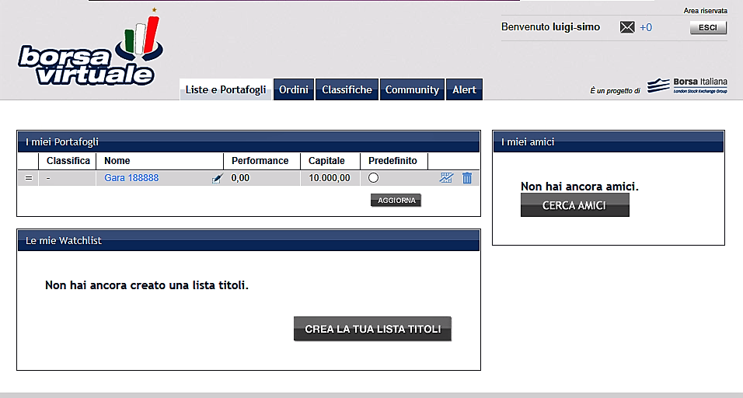

Figure A2. Borsa Virtuale: initial virtual capital
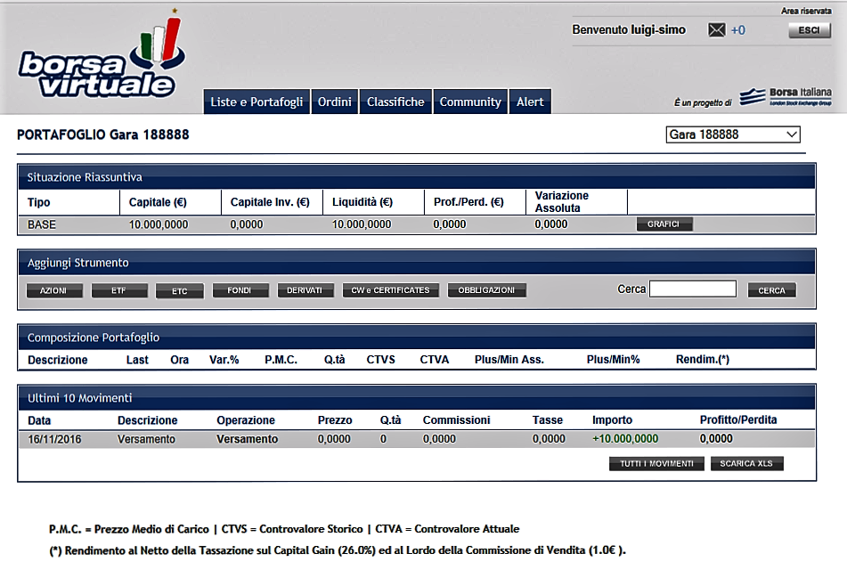

The virtual capital can be used to invest in all sectors that characterize the Italian Stock Exchange: stocks (Azioni), fixed income (Obbligazioni), financial derivatives (Derivati), mutual funds (Fondi), ETFs / Etc, Certificates e CW. For the chosen segment, one can view all the listed securities in alphabetic order (Figure A3: all listed securities in the equity segment whose name begins with the letter B).

Figure A3. Borsa Virtuale: table with all listed securities in alphabetic order

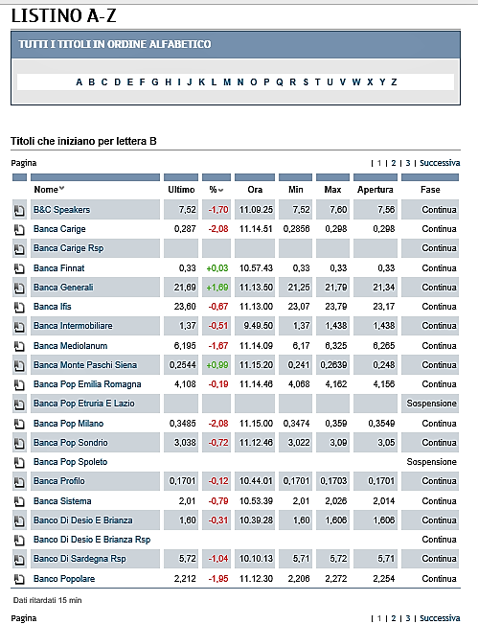

The virtual investor can then choose the security s/he likes to invest in, its quantity and the type of operation (buy, sell…) as shown in Figure A4.

Figure A4. Borsa Virtuale: trading

Buying Selling
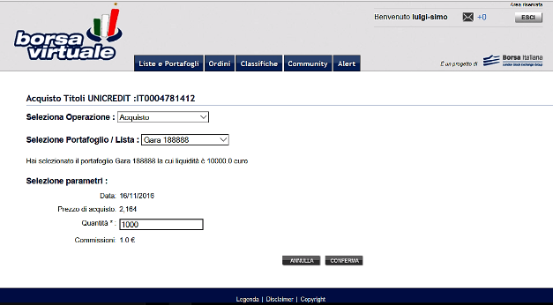

In any time, the system gives a full description of the portfolio and a synthetic indicator of its performance (Figure A5).

Figure A5. Borsa Virtuale: portfolio description (a) and performance (b)

(a)
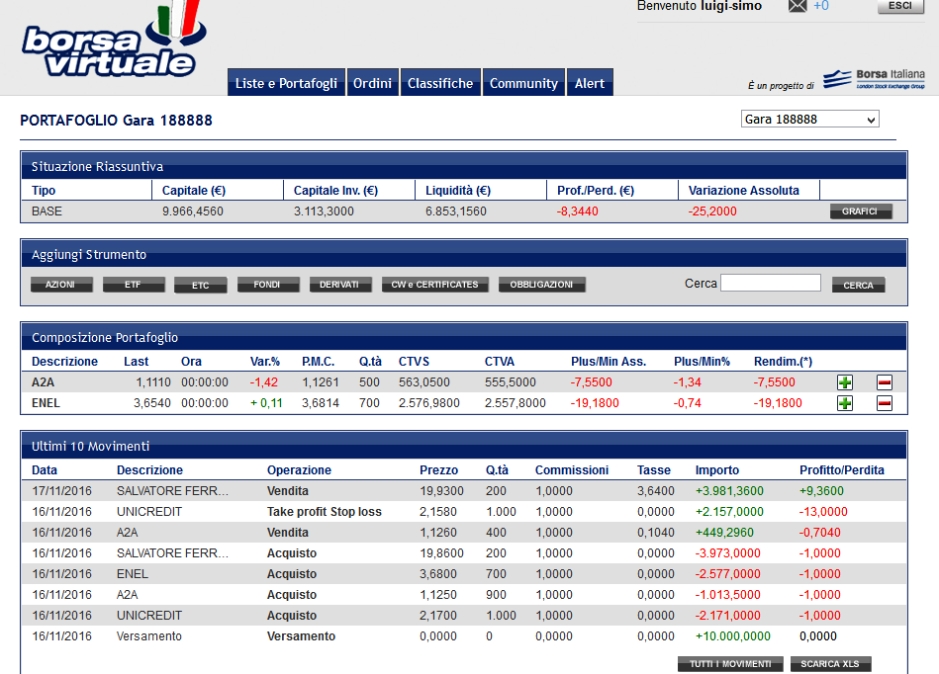

(b)
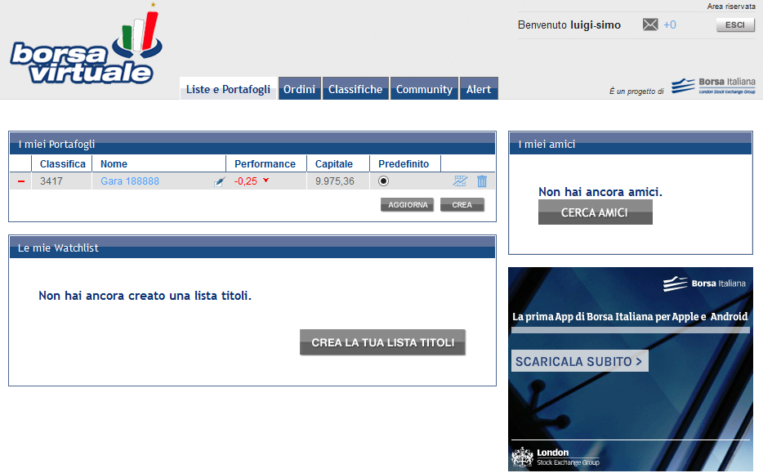

Also, information on listed companies as well as all technical analysis tools (see Figure A6 for an analysis with candlestick) are available to all virtual investors.

Figure A6. Borsa Virtuale: technical analysis tools

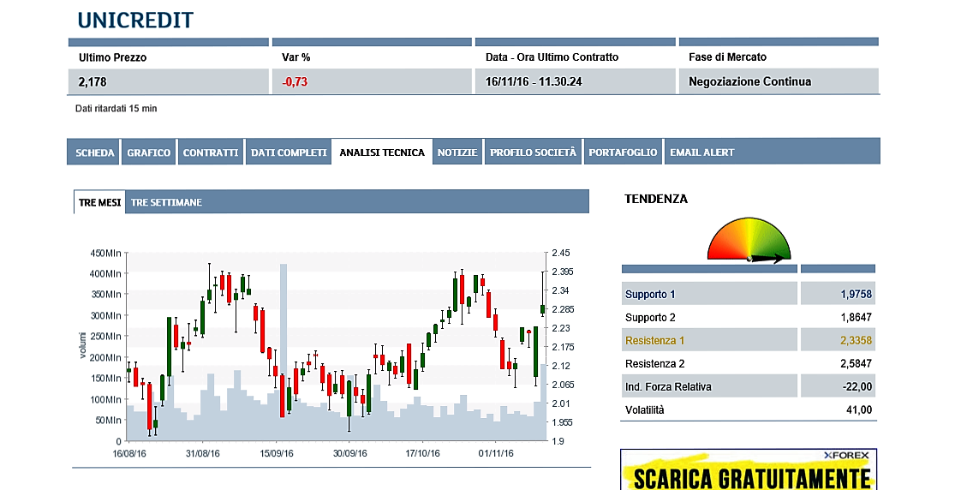

∗ M. De Paola, Department of Economics, Statistics and Finance, University of Calabria, Via Ponte Bucci, 87036 Arcavacata di Rende (CS), Italy, and Institute for the Study of Labor (IZA). E-mail: m.depaola@unical.it; F. Gioia, School of Economics, University of Edinburgh, 30 Buccleuch Place, Edinburgh, EH8 9JT, UK, and Department of Economics, Statistics and Finance, University of Calabria, Via Ponte Bucci, 87036 Arcavacata di Rende (CS), Italy. E-mail: f.gioia@sms.ed.ac.uk; F. Piluso: Department of Business Administration, University of Calabria, Via Ponte Bucci, 87036 Arcavacata di Rende (CS), Italy. E-mail: f.piluso@unical.it. We are grateful to the Dean of the Faculty of Economics at the University of Calabria for allowing us to run the experiment. We would like to thank Vincenzo Scoppa, Francis Breedon and seminar participants at the University of Calabria for useful comments and suggestions. Francesca Gioia gratefully acknowledges financial support from Economic and Social Research Council.
The University of Calabria is a middle-sized public university located in the South of Italy. It has currently about 30,000 students enrolled in different Degree Courses and at different levels of the Italian University system. Since the 2001 reform, the Italian University system is organized around three main levels: First Level Degrees (3 years of legal duration), Second Level Degrees (2 years more) and Ph.D. Degrees. In order to gain a First Level Degree students have to acquire a total of 180 credits. Students who have acquired a First Level Degree can undertake a Second Level Degree (acquiring 120 more credits). After having accomplished their Second Level Degree, students can enroll in a Ph.D. degree.
Behavioural biases were explained to students in the first part of the course, before announcing the availability of the additional activity.
In the Italian University System students can sit the exam as many time as they want without paying extra fees. The bonus awarded with the virtual credit activity was valid only in the first examination session (January).
The virtual trading platform is available at http://www.borsaitaliana.it/varie/loginservices/borsavirtuale/intro/borsavirtuale.htm. See the appendix for a more detailed description of Borsa Virtuale.
When a first draft of this paper was ready, we invited students to a seminar aimed at presenting and discussing the results of our research and students taking part to the seminar confirmed that they had not guessed the real purpose of our study.
Market performance was computed as (FTSE MIB at the liquidation date – FTSE MIB at the initial date) / FTSE MIB at the initial date.
This rule was included to avoid the possibility of deleting a portfolio not performing well and creating a new portfolio.
The randomization was run when the Borsa Italiana and the corresponding virtual platform where closed and negotiations were not allowed in order to have a picture of students’ situation in a determined moment in time. The behavioural insight message was sent soon before the reopening of the negotiations.
We decided to leave three weeks of negotiations after the message to take into considerations trading platform closing due to bank holiday over the Christmas period.
The same question is posed by the German Socio-Economic Panel (GSOEP, 2004).
The time effect is not different for treated and control participants.
We have also investigated heterogeneity along the gender dimension and we have found that the effect of behavioural insight messaging on portfolio performance is not different between men and women. Similarly, we do not find any statistically significant difference when looking at students characterized by different ability.
Results in columns (1) to (4) are robust if we include among controls the value of the dependent variable in the first two weeks of negotiations, before our messages were sent (Number of transactions before treatment in columns (1) and (2) and Percentage Foreign before treatment in columns (3) and (4)). As we have shown in Table 2, students were randomized based also on their trading activity.

